**Basic Pratice of Programming Experiment JobSheet 3**



**From:**

AL AZHAR RIZQI RIFA’I FIRDAUS

**Class:**

1 I

**Absence:**

01

**Major:**

Information Technology

**Study Program:**

Informatic Engineering

**Experiment 1**

1. Open a text editor

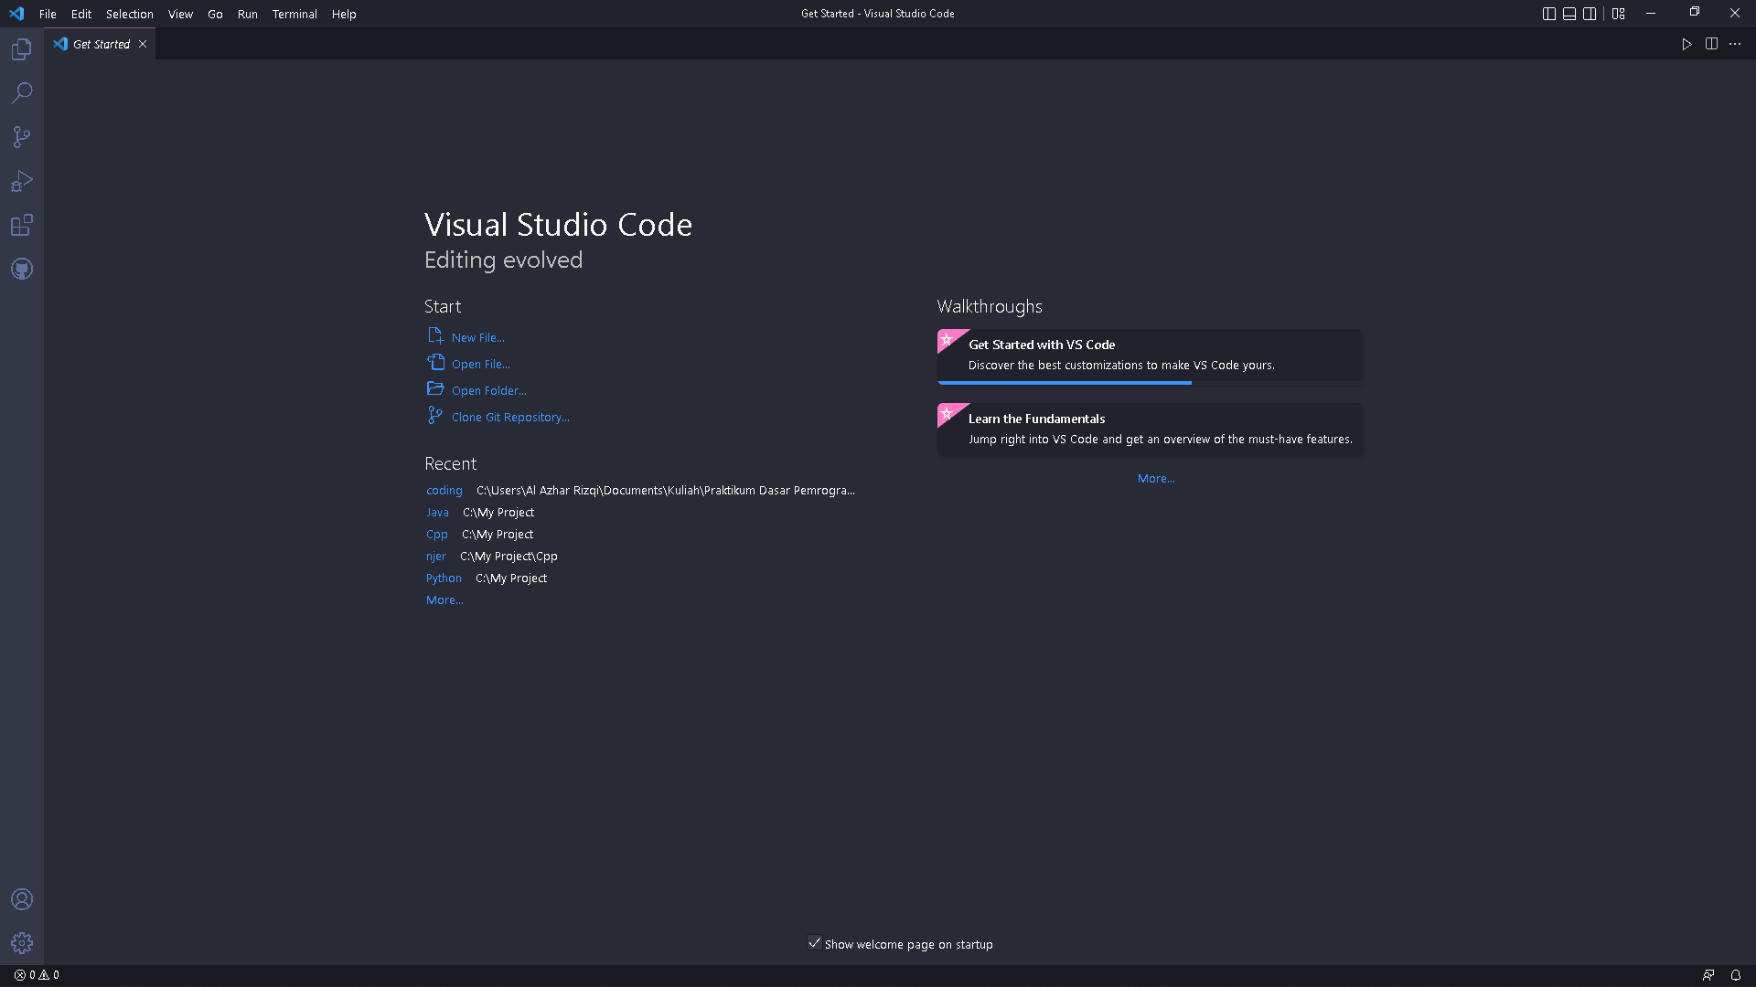

1. Create a new file, name it ExampleVariabel.java

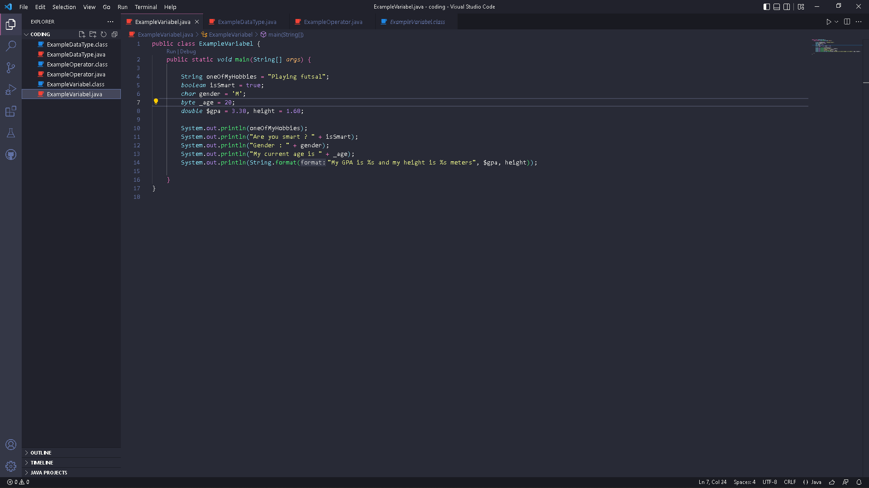

1. Write the basic structure of the Java programming language which contains the main() function

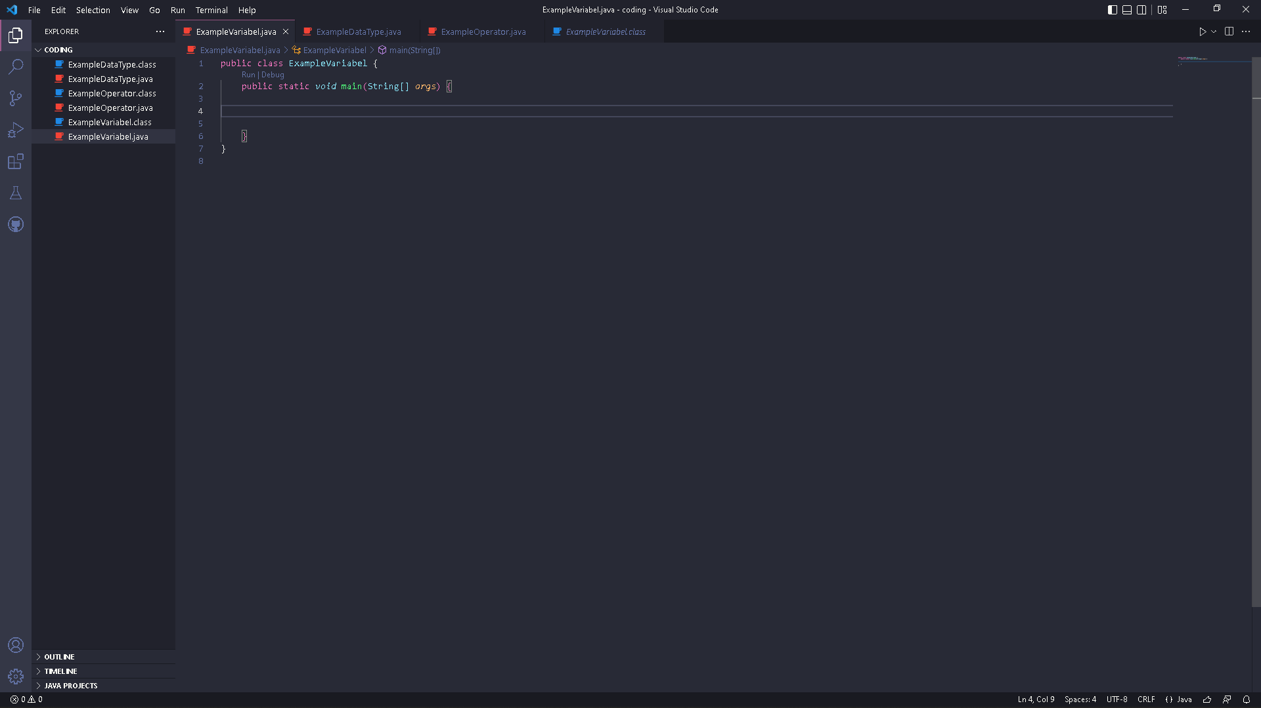

1. Write the code below in public static void main (String args [])

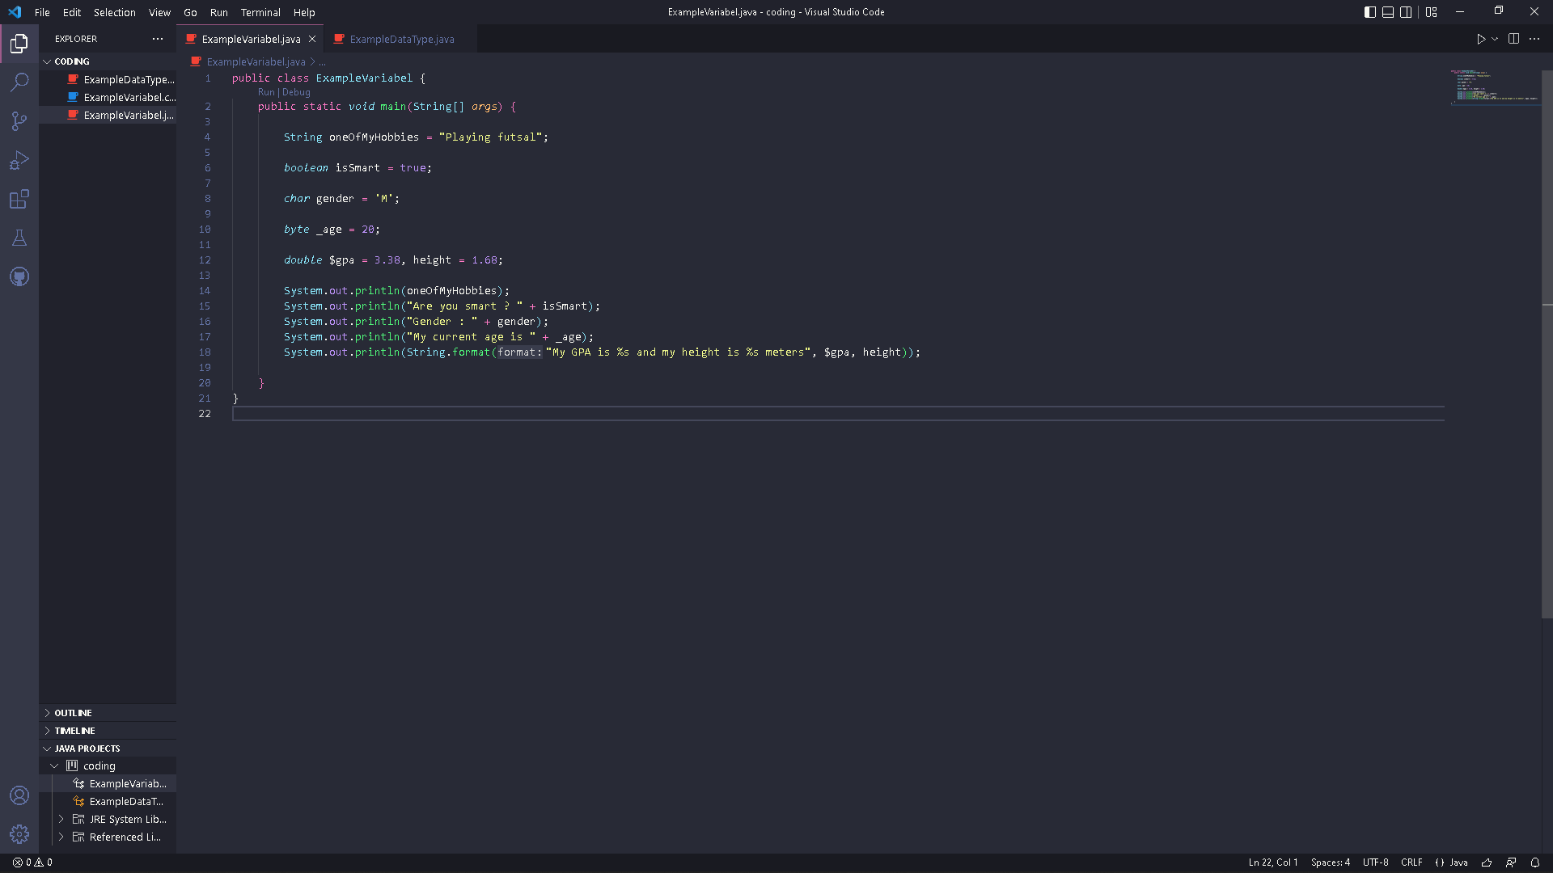

1. Run the program code that you have written, then observe the results

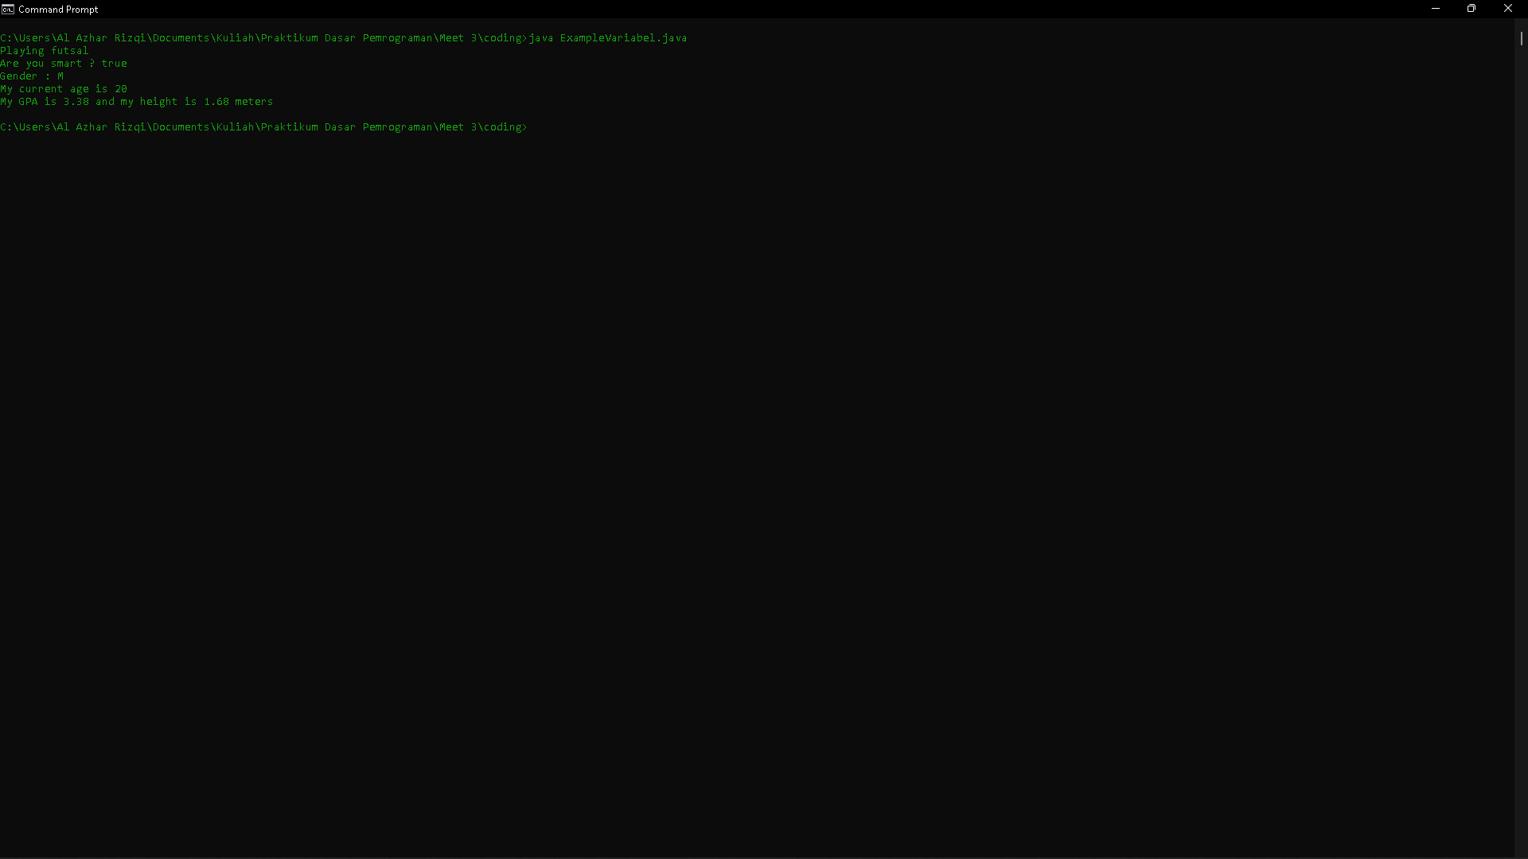

**Questions !**

1. Change the variable name so that the variable naming model is good and correct!

2. Run the code again and then observe the results!

**Answer**

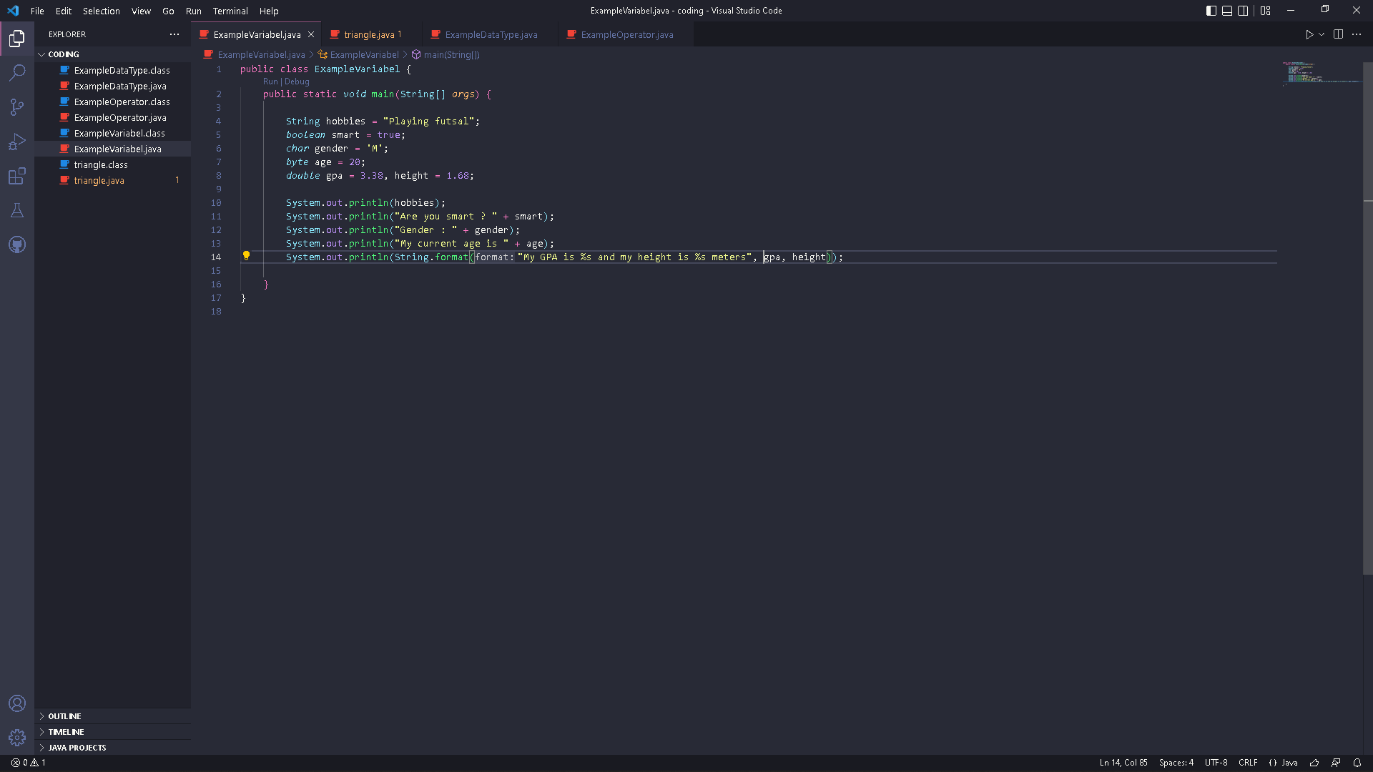

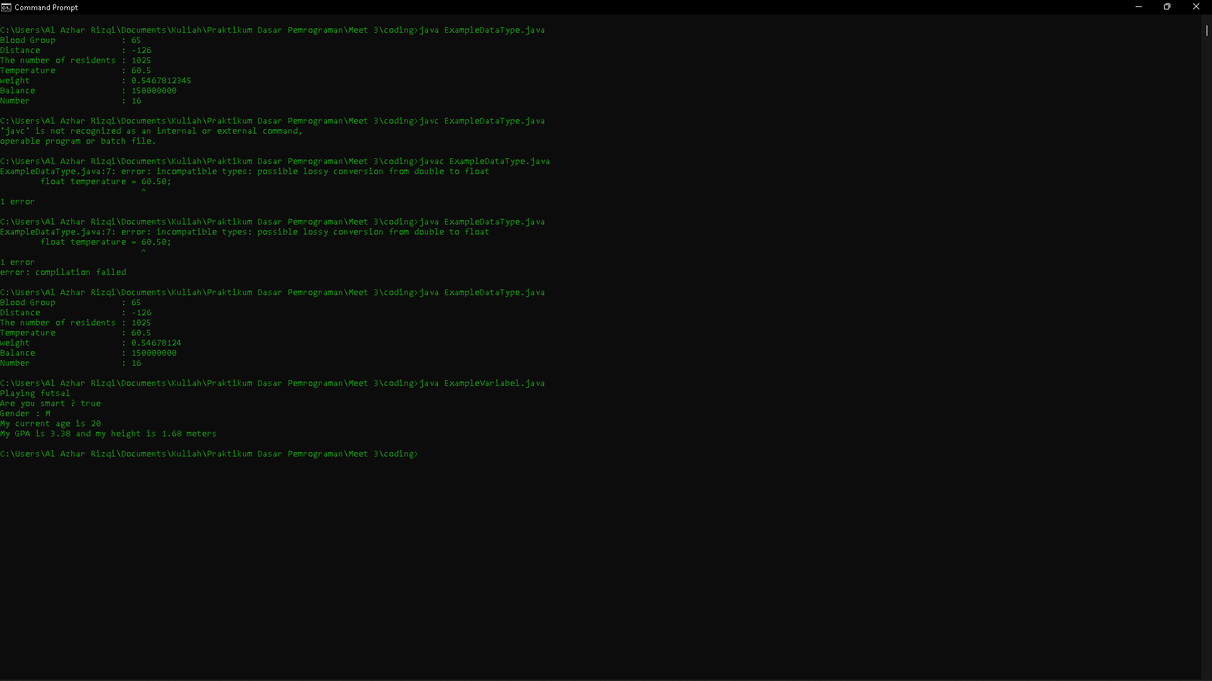

**Experiment 2**

1. Open a text editor



1. Create a new file, name it ExampleDataType.java

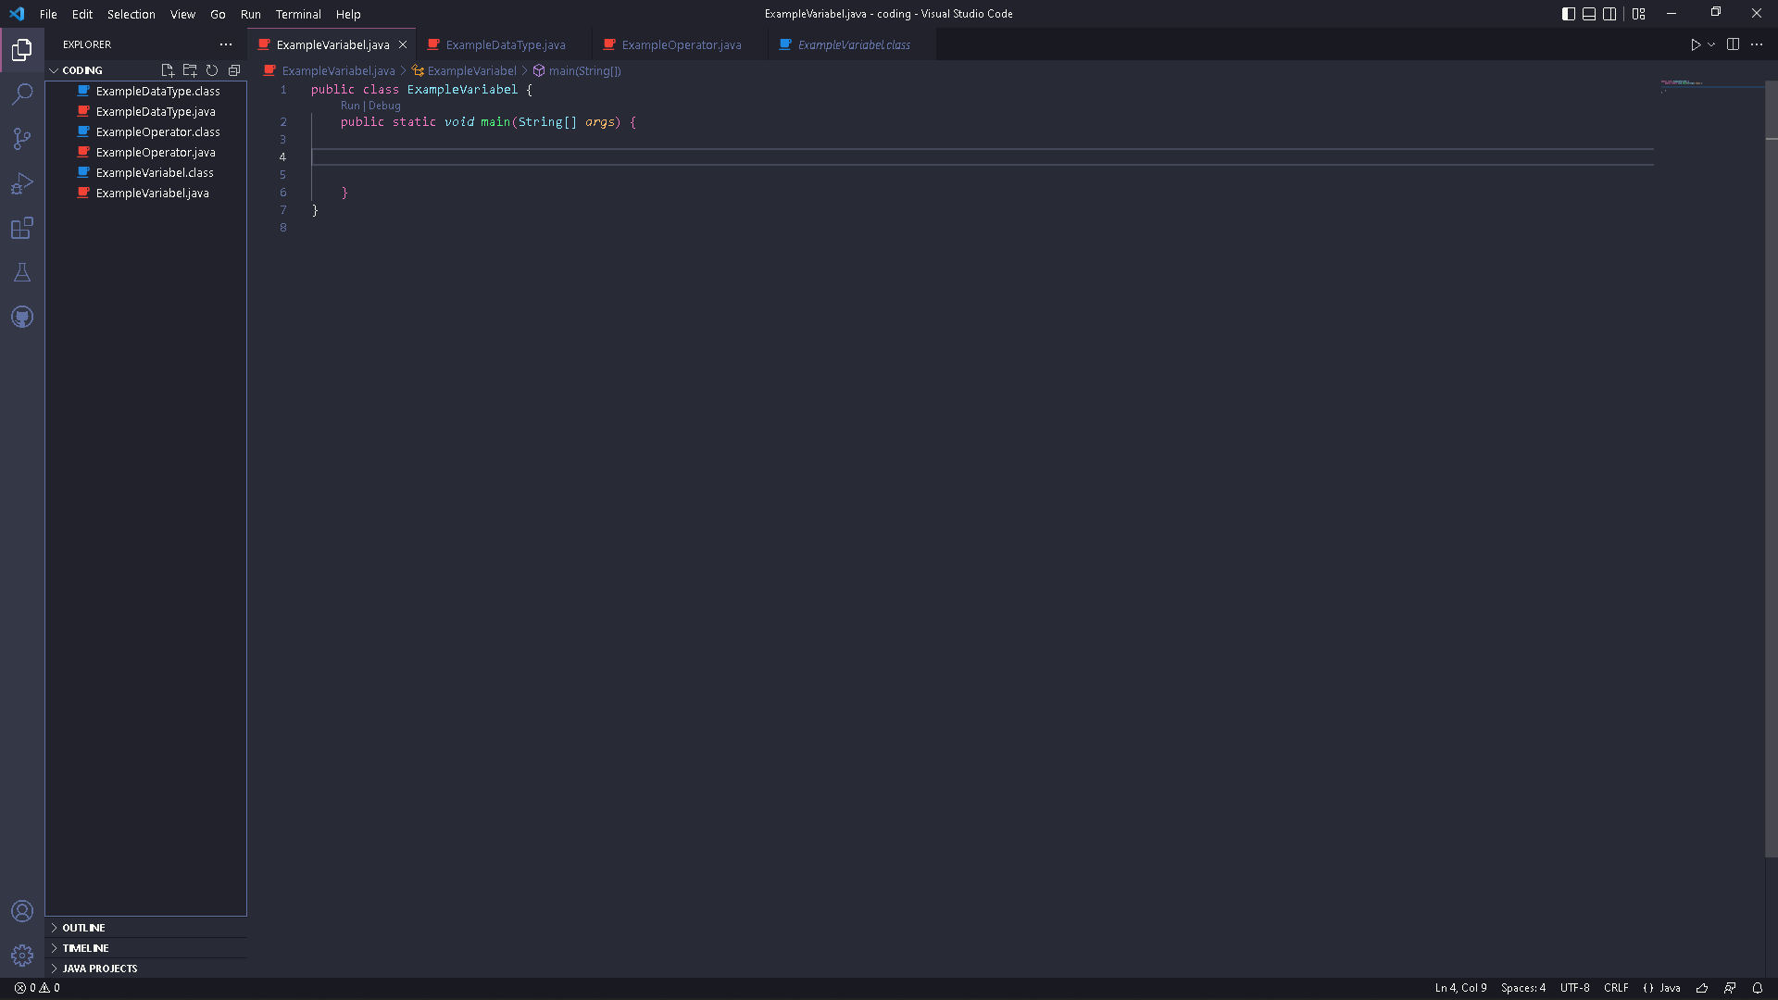

1. Write the basic structure of the Java programming language which contains the main() function

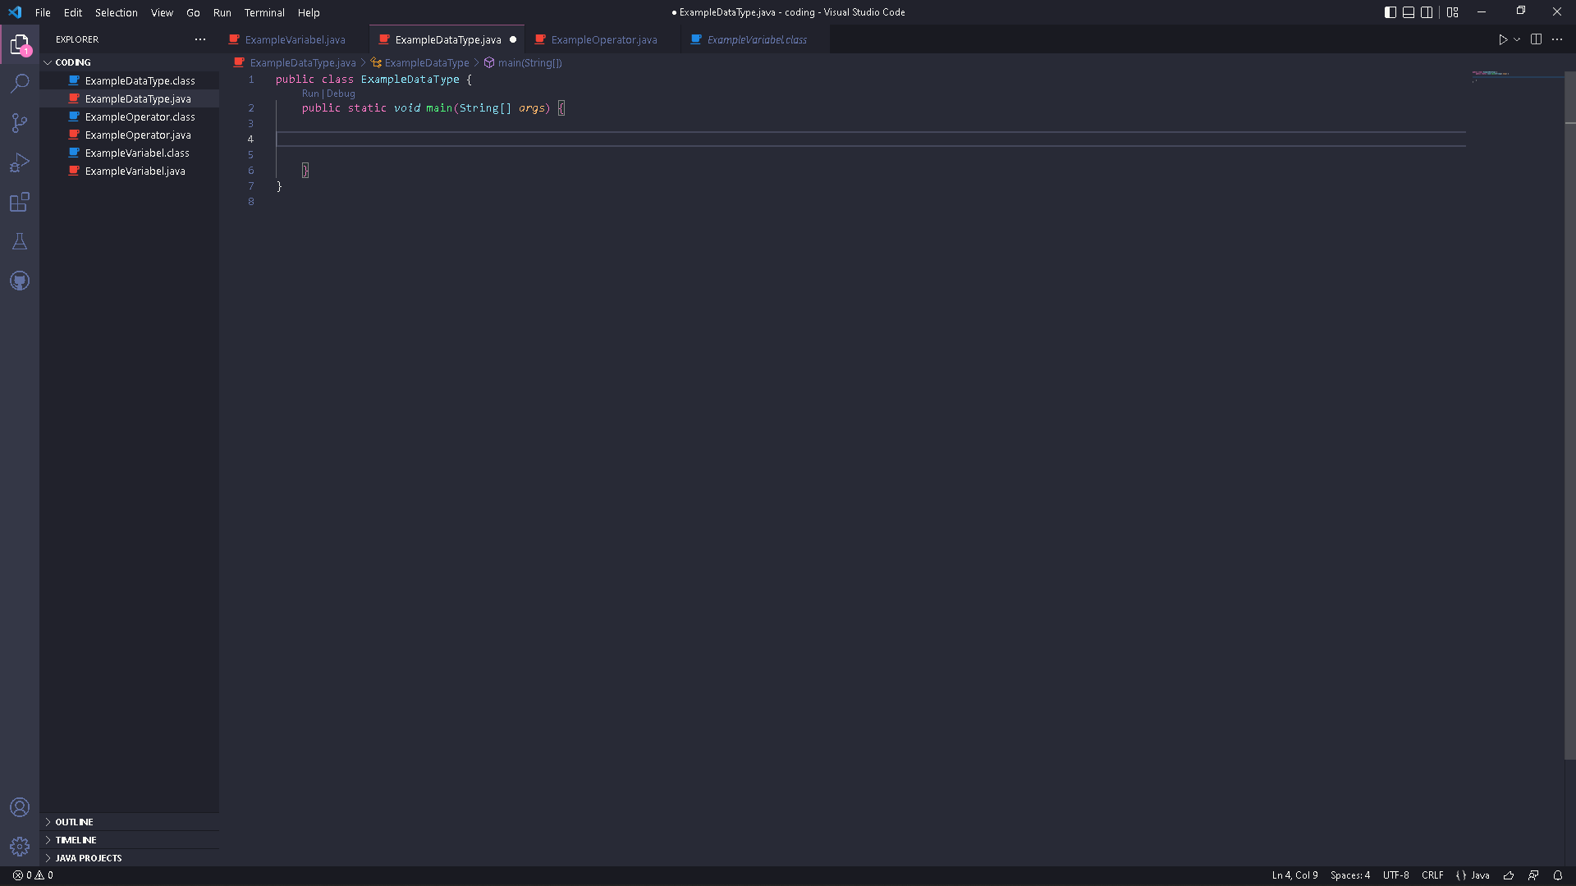

1. Write the code below in public static void main (String args [])

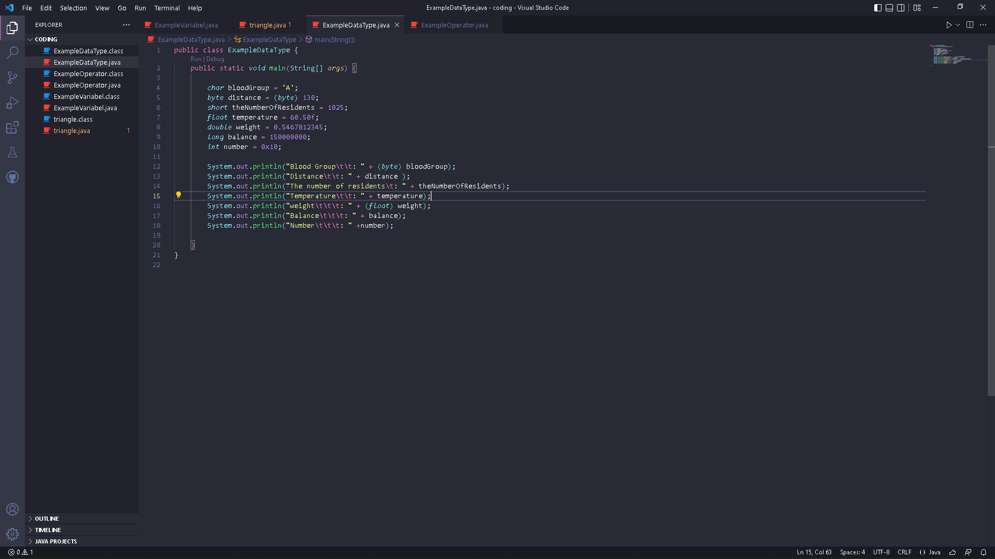

1. Run the program code that you have written, then observe the results

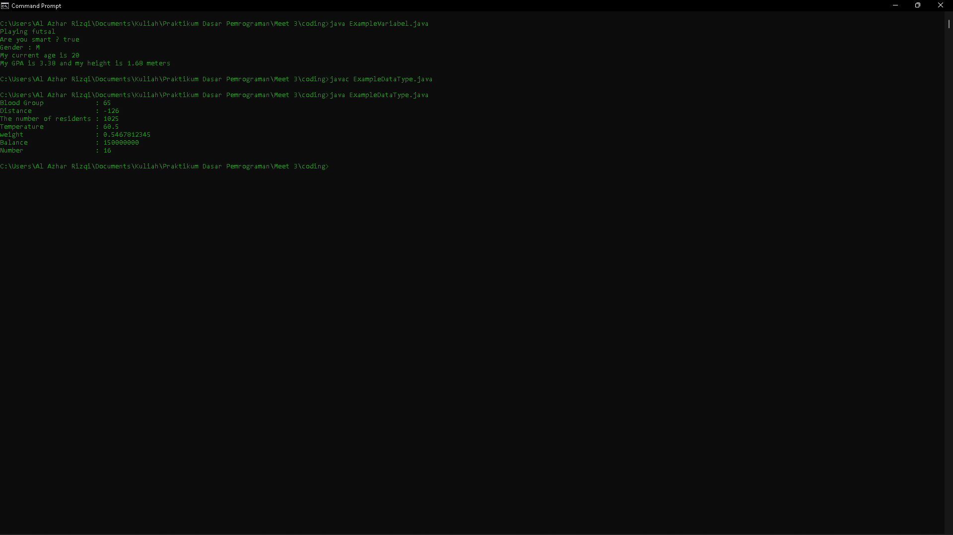

**Questions!**

1. Explain why the blood group does not display an "A"!

2. Explain the syntax of distance = (byte) 130 bytes! Then, explain why the results change when displayed!

3. In the syntax float temperature = 60.50F; remove the letter F, then run again. What happened?

4. Why does the result change when displaying weight values?

5. Explain the meaning of initializing 0x10 on number variables! What does it do?

**Answer**

1. Because in sout there is syntax (byte). If syntax (byte) removed, the “A” will display.
2. Syntax of distance = (byte) 130 bytes, are bytes of the data values. Not the value of variable. Because declared are bytes of number 130. If we want to display the number of 130, changed to byte distance = 130; and then System.out.print.ln(“Diistance : ” + distance);
3. Code after remove :

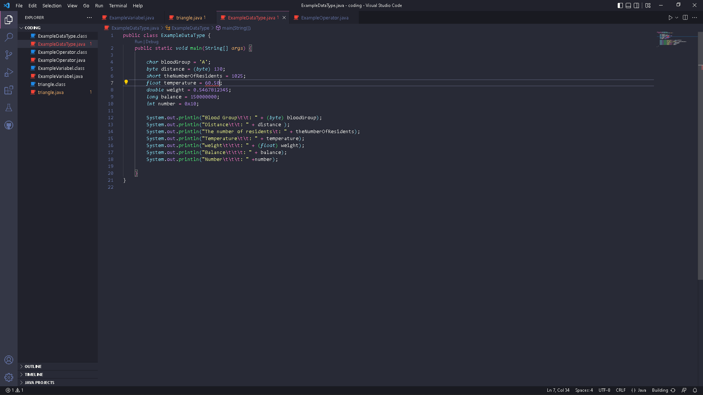

Result :

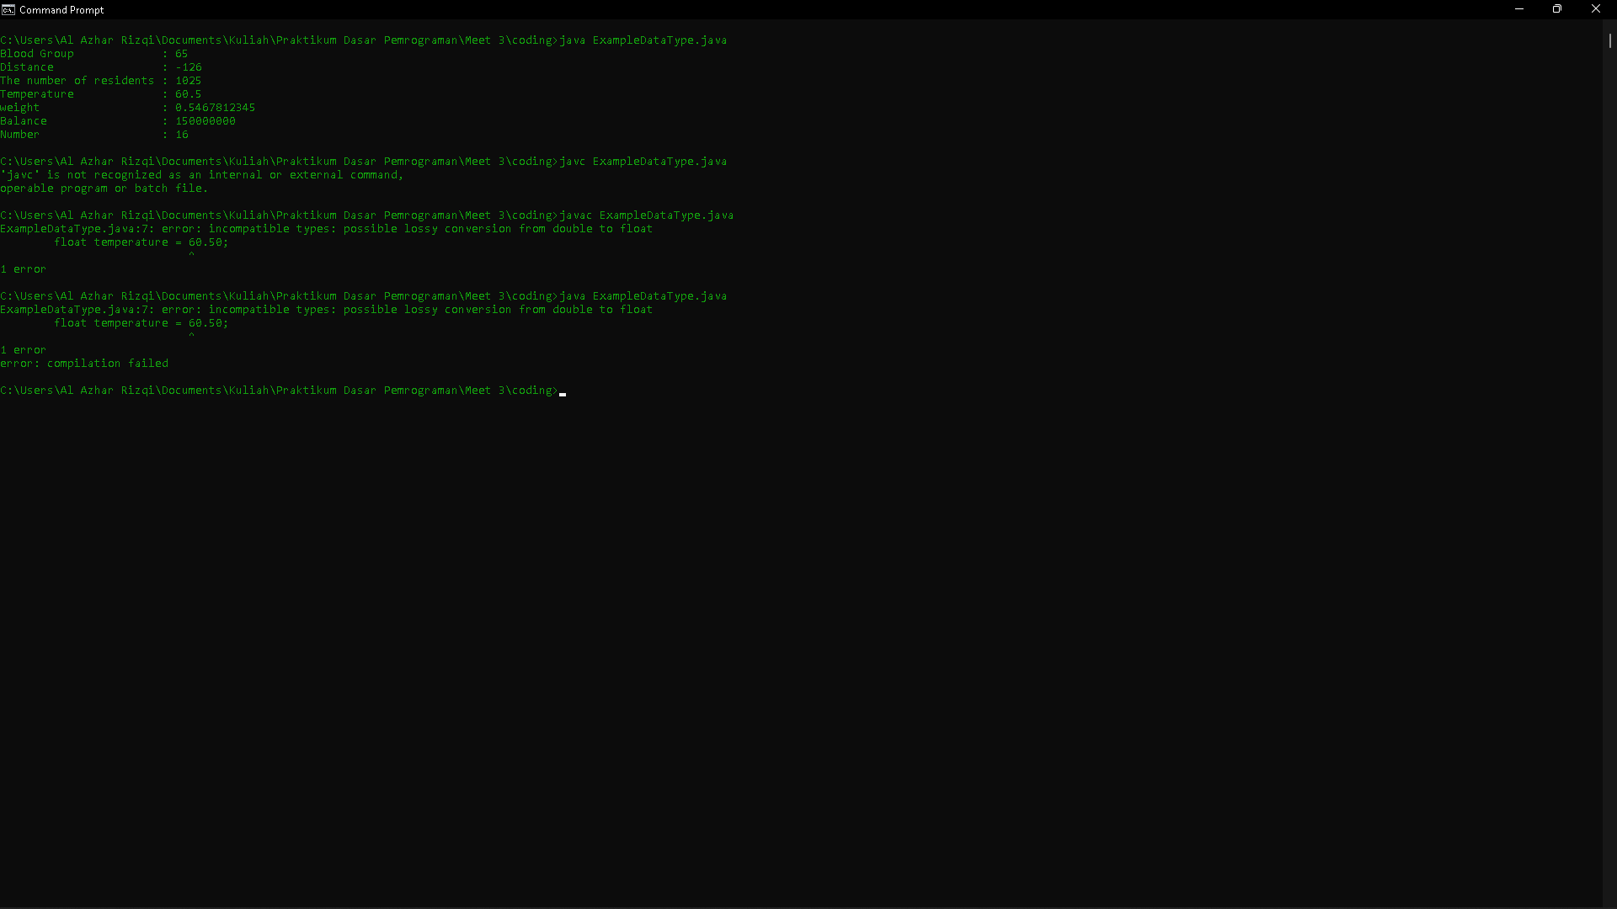

The program can’t running because cannot convert from double to float.

1. Because in sout of weight has been casting be float.
2. 0x10 is hexadecimal number. The function to display hex number in decimal which is 16.

**Experiment 3**

1. Open a text editor



1. Create a new file, name it ExampleOperator.java
2. Write the basic structure of the Java programming language which contains the main() function
3. Write the code below in public static void main (String args [])

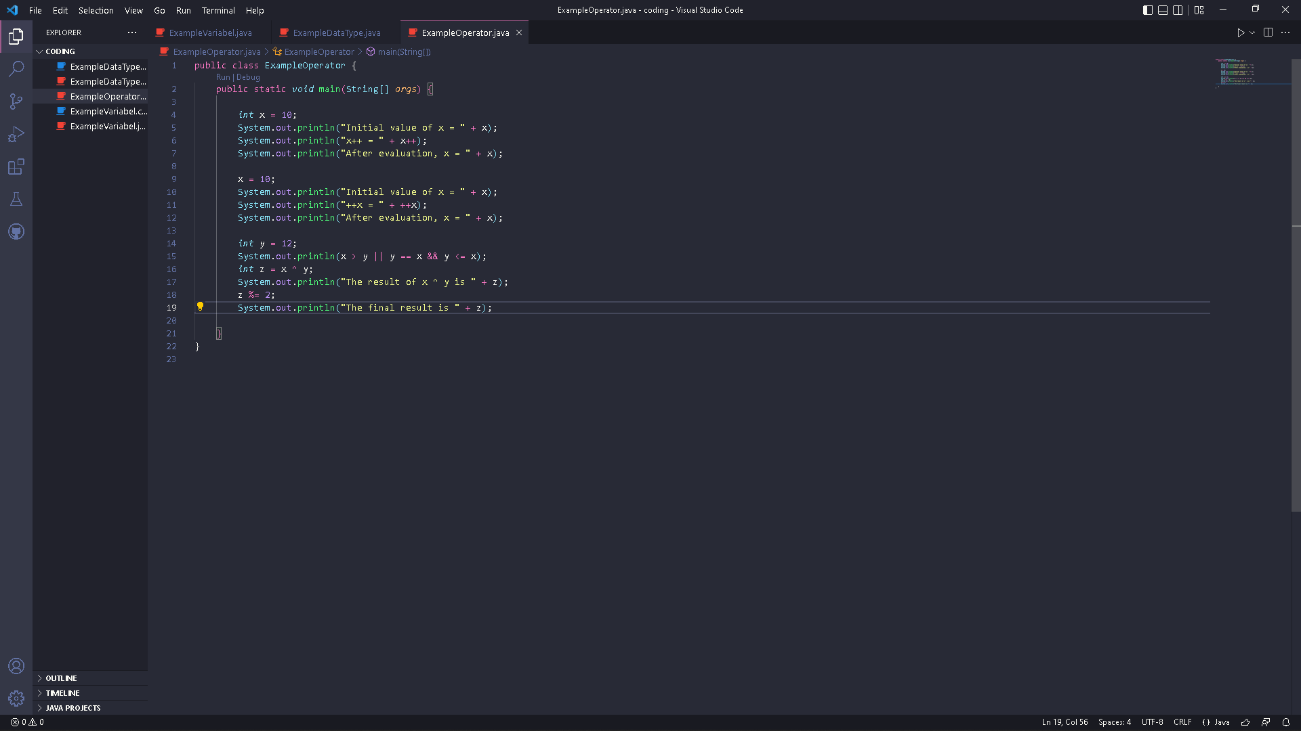

1. Run the program code that you have written, then observe the results

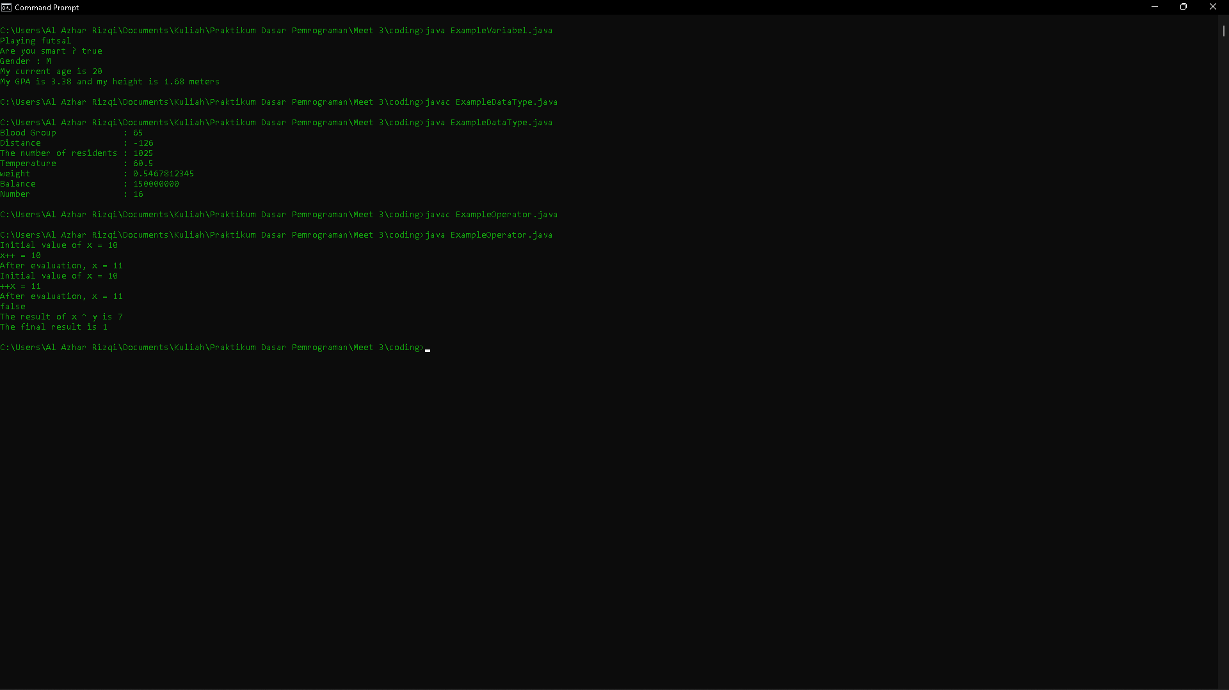

**Questions!**

1. Explain in your opinion what is the difference between x++ and ++x!

2. What is the result of int z = x ^ y; do the calculations manually (you can use a calculator)!

**Answer**

1. X++ are use the variable of x first, then add 1 to variable x.

++x are add 1 to variable x first, then use the variable of x. reversal off x++.

1. The result is 7. The calculator :

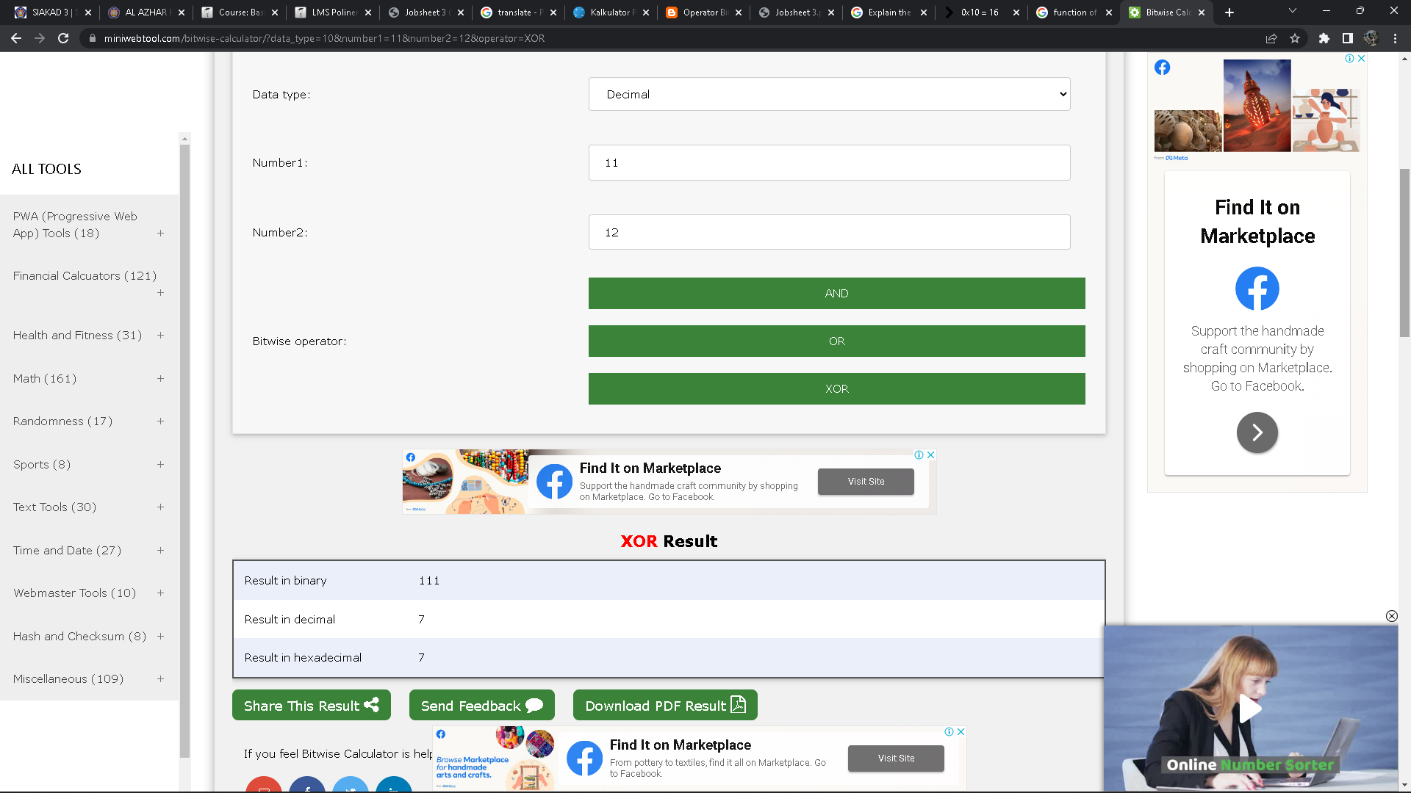

**Experiment 4**

1. Create a new file named triangle.java

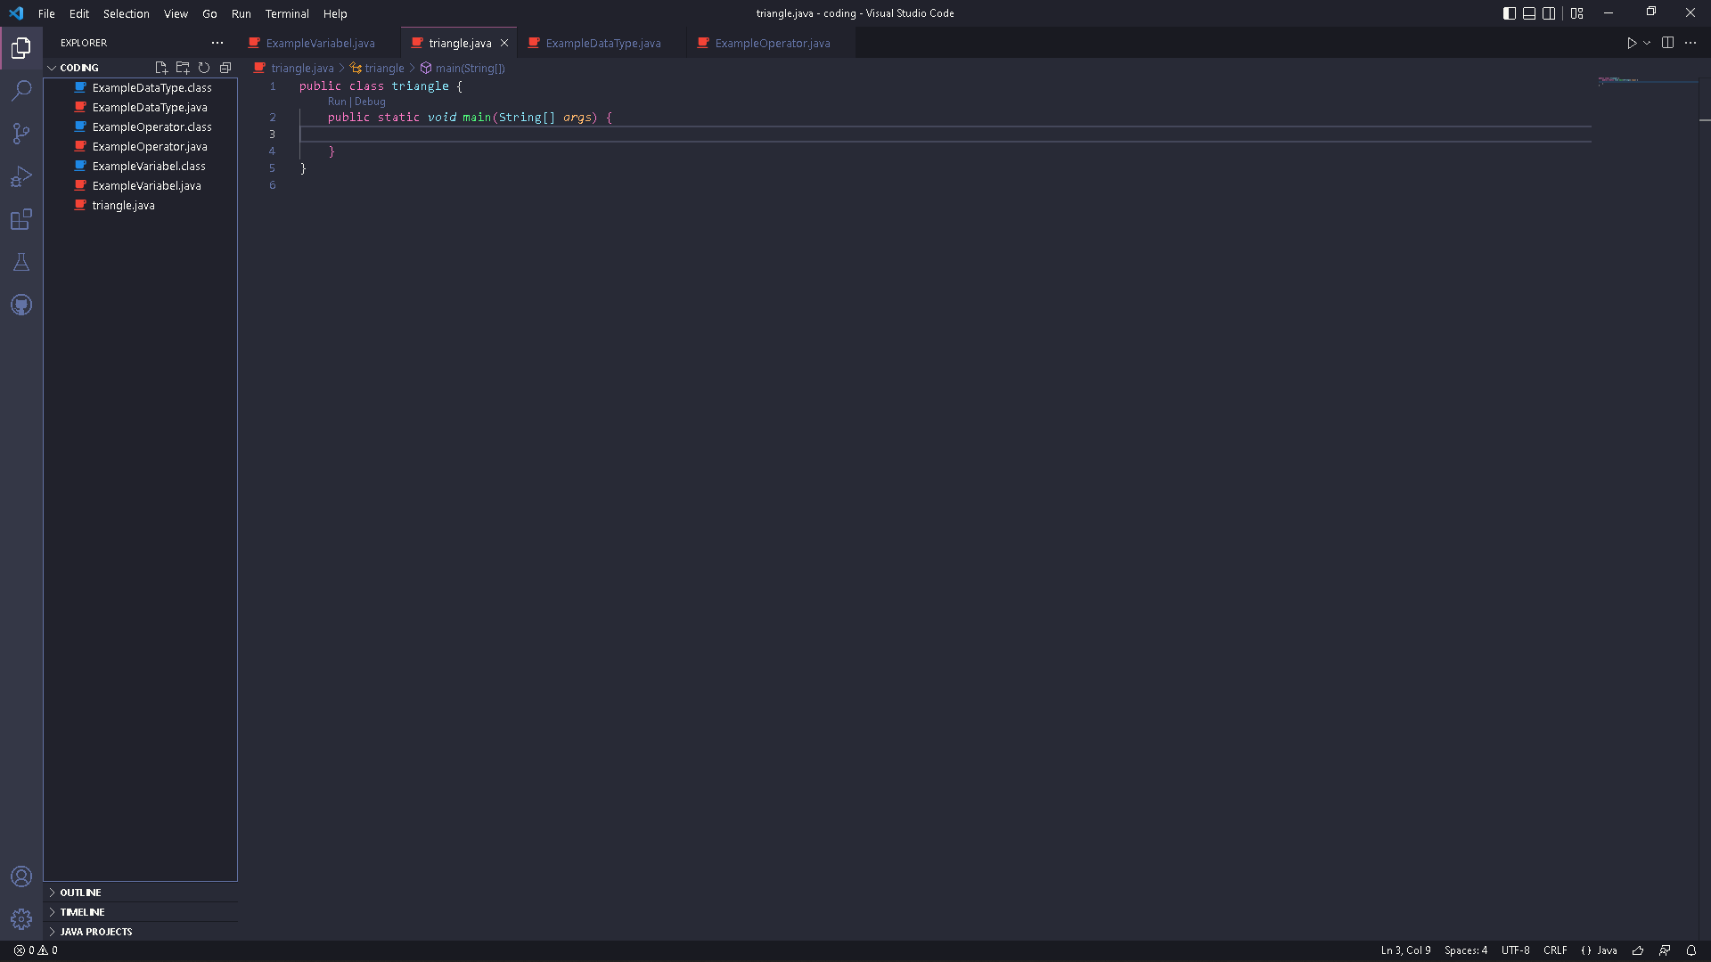

1. Observe the flowchart to calculate the area of the following triangle

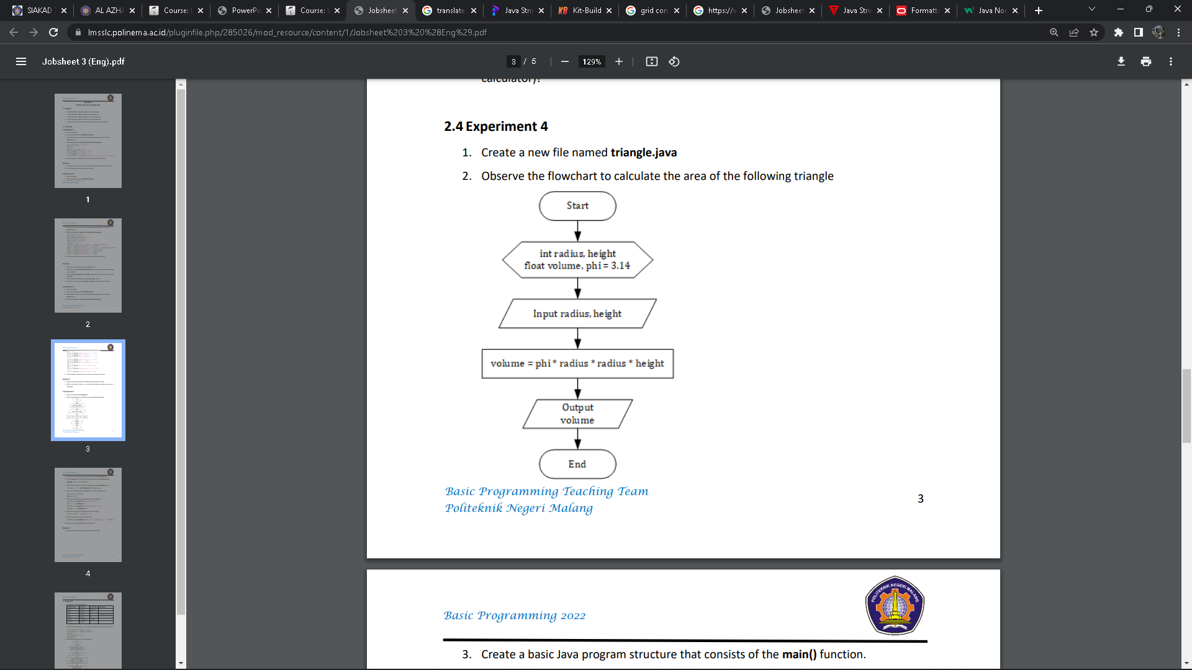

1. Create a basic Java program structure that consists of the main() function.



1. Add the Scanner library. Write the following code at the top outside the class

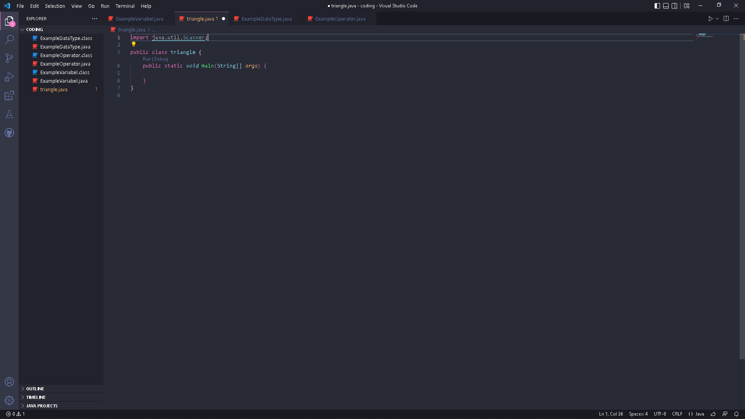

1. Make a Scanner declaration. Write the following code in the main() function

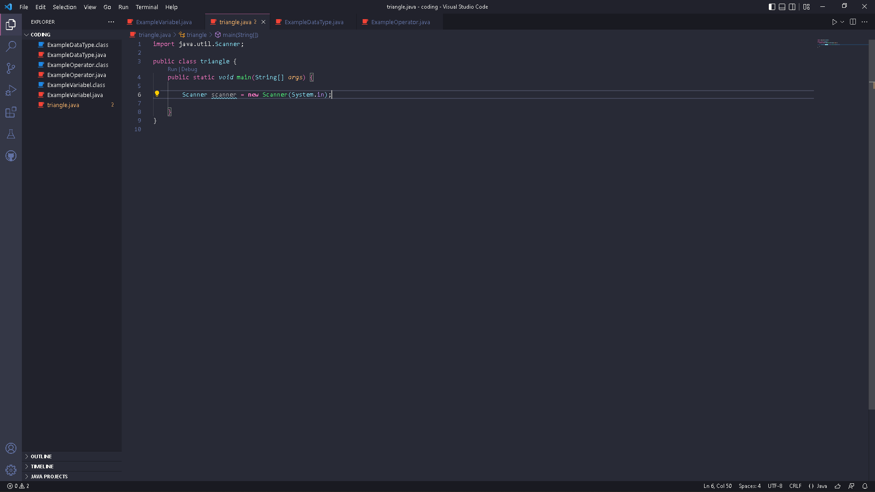

1. Create an int variable for base and height, then a float variable for area.

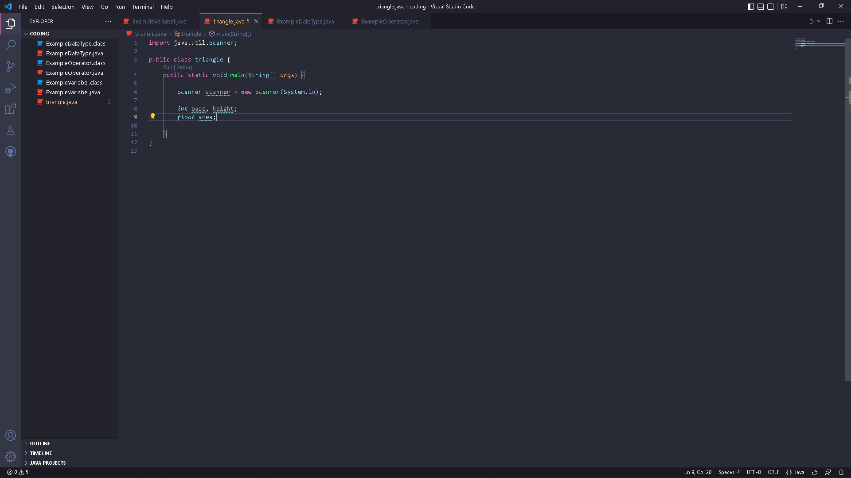

1. Write down the syntax for inputting the base and height values

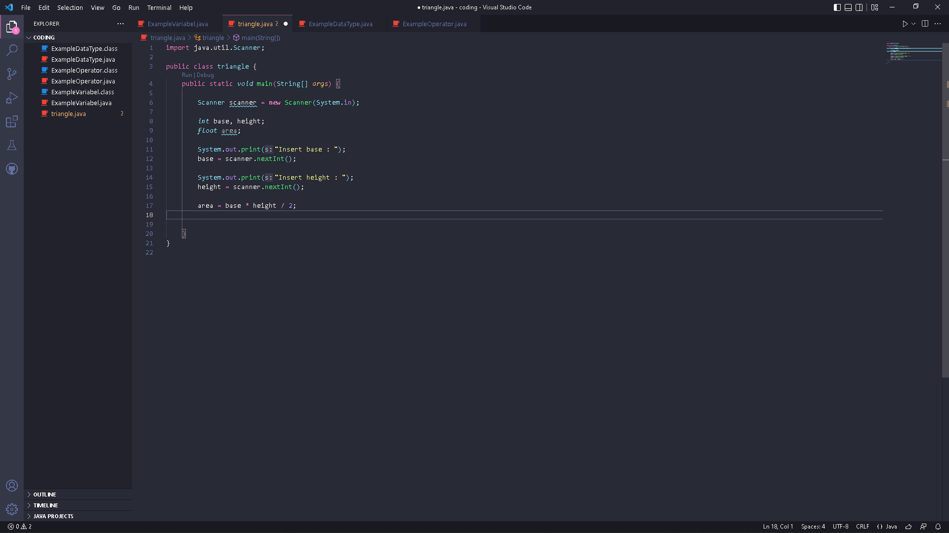

1. Write down the syntax for calculating the area of a triangle



1. Print the calculation of the area of the triangle

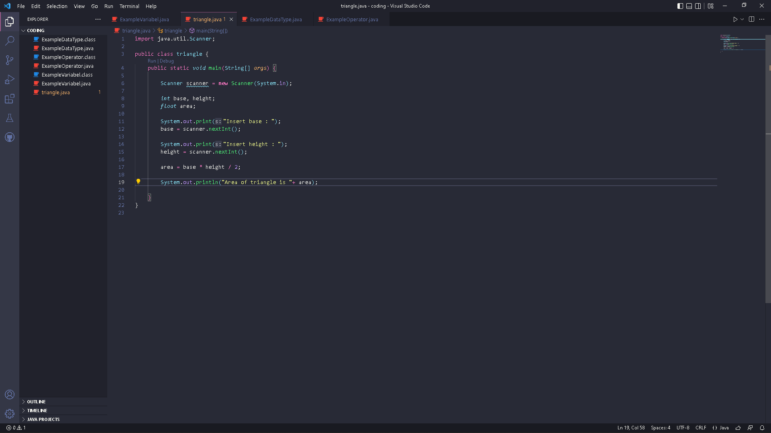

1. Compile and run the program. Observe the results!

* Code :



* Result :

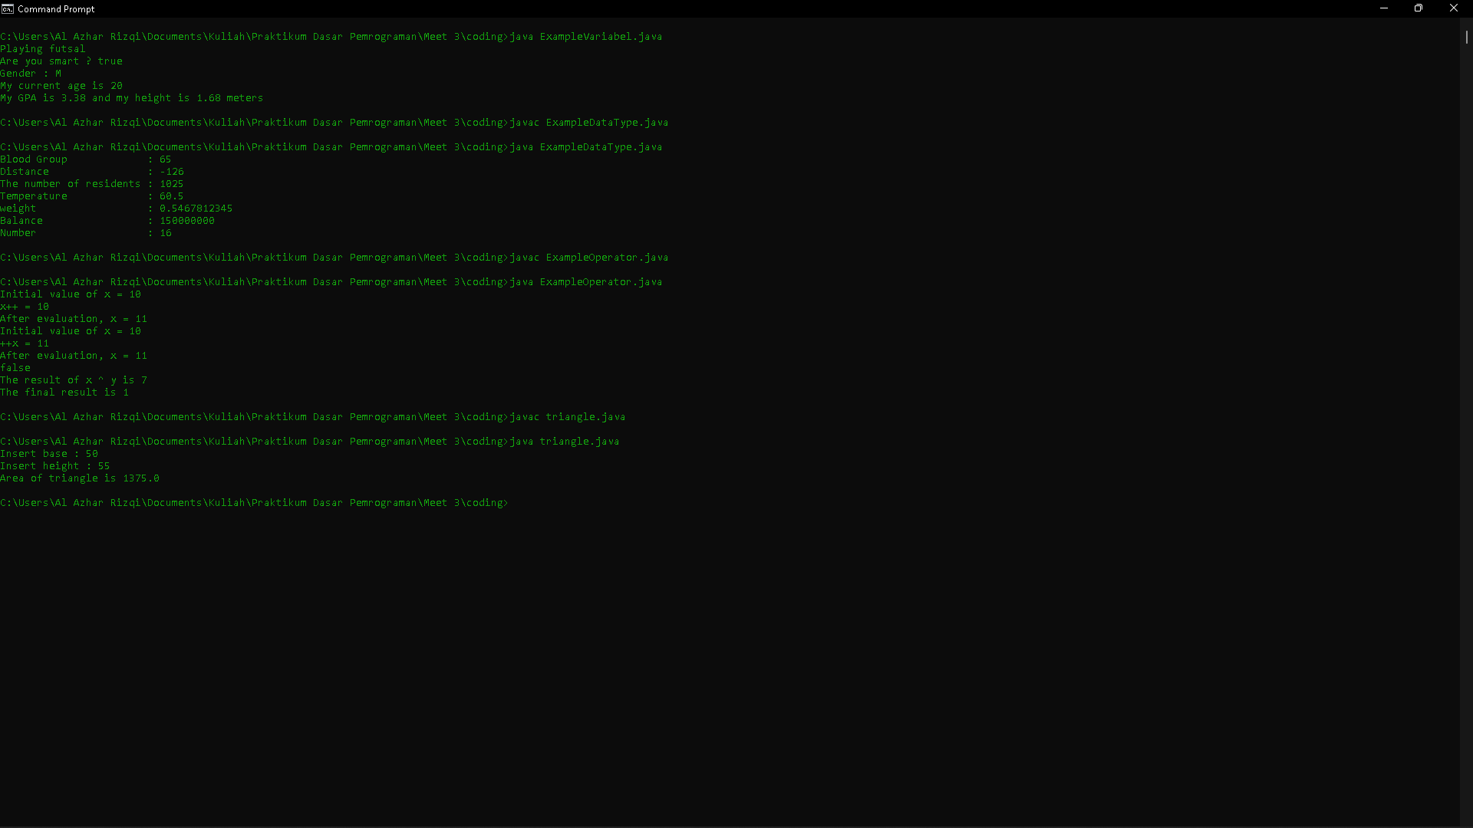

**Questions!**

1. Explain why the float data type is used for the variable area!

**Answer**

1. Because the result of area can be decimal, so that we used float or double, not integer.